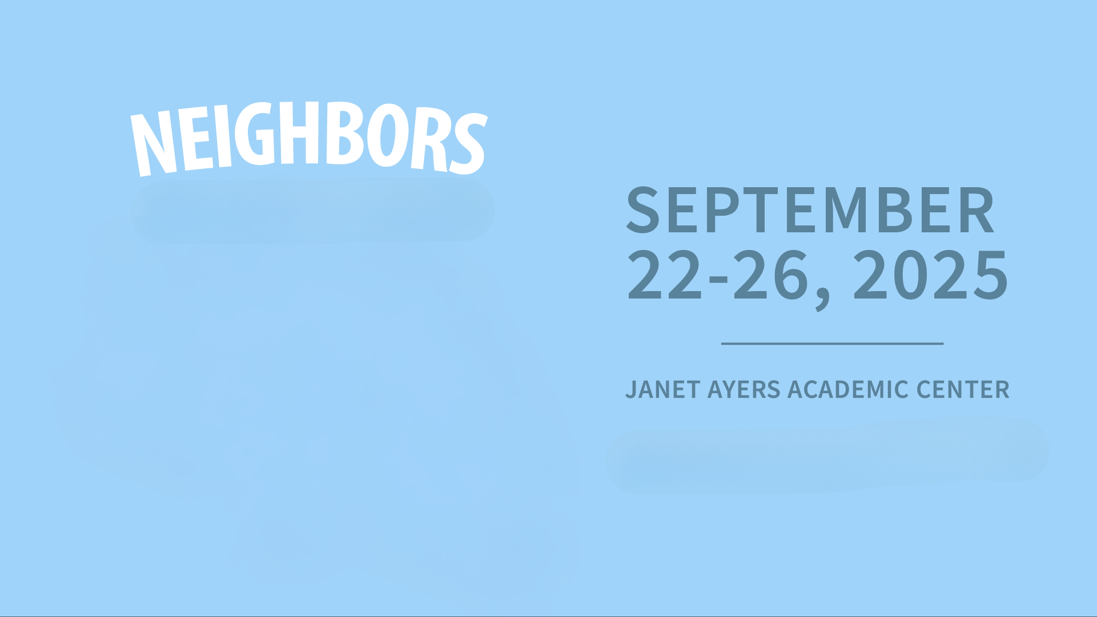

**MONDAY, SEPT. 22, 2025** **Seek Excellence with Humility** **Janet Ayers Academic Center: 4th Floor Conference Room**

|  |  |
| --- | --- |
| **Time** | **Event** |
| 9:30 | **SYMPOSIUM KICKOFF!** - Join us for opening remarks to kick off the 24th Annual Humanities Symposium |
| 10:00 | **FEATURED SPEAKER: KHALIL EKULONA** - "All Are Invited: How Honor, Authenticity, & Grace Guides us through Divisive Times" |
| 11:00 | **DR. JOEL OVERALL** - "The Monteverde Lecture: Where Everyone Knows Your Name: How to be a Regular" |
| 12:00 | **DR. CHARMION GUSTKE, DR. DOUGLAS MURRAY, DR. NATHAN GRIFFITH** - "The Closer We Are Together the Further We Are from Care (or so it seems)" |
| 1:00 | **WELCOME RECEPTION** |
| 2:00 | **CHRIS THIESSEN** - "Listening for the Love of Neighbor: How Popular Music Participates in the Pursuit of Just Relationships" |
| 6:00 | **"ROOTS SO DEEP" PT. I** - Documentary Screening (*1890 Theater, Jack C. Massey Center) |

**TUESDAY, SEPT. 23, 2025** **Offer Gratitude with Joy** **Janet Ayers Academic Center: 4th Floor Conference Room**

|  |  |
| --- | --- |
| **Time** | **Event** |
| 11:00 | **DR. ANN COBLE** - "Who Is My Neighbor? Reflections on the Parable of the Good Samaritan" |
| 12:30 | **DR. KACIE HITTEL & PROFESSOR DAN BRAWNER** - "Seeing Our Non-Human Neighbors: A Drawing and Writing Workshop" |
| 2:00 | **JEFF MOLES, JASMINE LEDSINGER, AMANDA CLELLAND** - "Nashville Neighbors: Room in the Inn, The Store, and Thistle Farms" |
| 3:30 | **DR. KEVIN TROWBRIDGE, DR. ANNA GRACE USERY, DR. CHRISTIE KLEINMANN** - "Won't You Be My (AI) Neighbor? The Reconceptualization of Relationships in the Age of Artificial Intelligence" |
| 6:00 | **"ROOTS SO DEEP" PT. II** - Documentary Screening (*1890 Theater, Jack C. Massey Center) |

**WEDNESDAY, SEPT. 24, 2025** **Unleash Hospitality with Love** **Janet Ayers Academic Center: 4th Floor Conference Room**

|  |  |
| --- | --- |
| **Time** | **Event** |
| 9:00 | **DR. MICHELLE E. SHAW** - "Rhetoric Next Door: How We Talk About the Neighbor" |
| 10:00 | **FEATURED SPEAKER: TOM JUNOD** - "Be a Man: Mister Rodgers, My Father, and Me" |
| 11:00 | **DR. KACIE HITTEL** - "How to Be a Derry Girl" |
| 12:00 | **DR. BARRY BALLINGER** - "Don't You Be My Neighbor: Criminalizing Neighborliness Through Zoning" |
| 1:00 | **DR. JUDY SKEEN** - "Neighbors with Paws, Claws, and Hooves" |
| 2:00 | **DR. NOEL BOYLE** - "Doulia Neighborhood: Kittay on Dependency and Community" |
| 3:00 | **TOM JUNOD** - "Student Writing Workshop" (*RSVP Required) |
| 6:00 | **"ROOTS SO DEEP" PT. III** - Documentary Screening (*1890 Theater, Jack C. Massey Center) |

**THURSDAY, SEPT. 25, 2025** **Live the Dream Together with Hope** **Janet Ayers Academic Center: 4th Floor Conference Room**

|  |  |
| --- | --- |
| **Time** | **Event** |
| 9:30 | **JOYCE SEARCY** - "Life, Liberty, and the Pursuit of Happiness: Chasing the American Dream with Your Neighbor" |
| 11:00 | **FEATURED SPEAKER: DR. ERIC CALDERWOOD** - "Bridges and Borders in the Legacy of Al-Andalus" |
| 12:30 | **DR. CHRISTINA ANANIAS** - "Joining Our Neighbors in Worship: Strengthening Intergenerational Ties Through Music" |
| 2:00 | **DR. BLAKE W. REMINGTON** - "Watching, Looking, Viewing: Neighbors Then and Now" (*Brief talk in Ayers, then walk to "Some Were Neighbors" Holocaust Exhibition at Bunch Library) |
| 4:30 | **Reception & Gallery Talk** - "Neighbors: Artist in Residence at Arcade Arts" (Leu Art Gallery) |
| 6:00 | **"ROOTS SO DEEP" PT. IV** - Documentary Screening and Panel Discussion with Featured Farmers (*1890 Theater, Jack C. Massey Center) |

**FRIDAY, SEPT. 26, 2025** **S.O.U.L.** **Janet Ayers Academic Center: 4th Floor Conference Room**

|  |  |
| --- | --- |
| **Time** | **Event** |
| 9:00 | **DR. BETH RITTER-CONN** - "Divine Disruption: The Gift and Challenge of Radical Hospitality" |
| 10:00 | **PHILOLOGOI PHILOSOPHY CLUB** - "Join us for a moderated discussion with Philosophy Faculty and Students" |
| 11:00 | **DR. DAVID DARK** - "Art, Empire, & the End of the World: Loving My Neighbor in the Everyday Apocalypse" |
| 11:45 | **Teaching Center Luncheon** - Service Learning Panel Discussion (*RSVP Required) |
| 1:00 | **DR. RAY CHAO** - "Neighbors, Fear, and the Law: The Trayvon Martin Case and Its Legacy" |
| 2:00 | **SANDRA HUTCHINS** - "Creative Writing Awards: Featured Readings: Student Writers" |
| 4:00 | **FEATURED SPEAKER: C.J. SENTELL** - "Neighbor as Verb: Practicing the Politics of Hospitality" |
| 5:00 | **Closing Reception** - Food catered by The Nashville Food Project |

**Special Thanks to The Louie M. & Betty M. Phillips Foundation**



